3ª PRUEBA DEL NACIONAL GT8

INVITACION.
El Club MODELCAR CMC de Cerdanyola tiene el placer de invitarles ala 3ª prueba del campeonato nacional.
La prueba se celebrará en el circuito del Club los próximos días 2,3 y 4 de octubre.
https://www.google.es/maps/place/Circuito+RC+Modelcar+Dub%C3%A0/@41.5020275,2.1350099,17z/data=!3m1!4b1!4m6!3m5!1s0x12a495fd7868a999:0x8e597fa6758b7c21!8m2!3d41.5020275!4d2.1375848!16s%2Fg%2F11c5485n65?entry=ttu&g_ep=EgoyMDI0MDkxOC4xIKXMDSoASAFQAw%3D%3D
DESCRIPCION DE LAS INSTALACIONES.
-270 m de cuerda del circuito
-Recta de 70 m y parabólica de 50 m
-Boxes cubiertos para 90 pilotos y toma de corriente en cada mesa
-Lavabo
-Zona de Compresor
-Parking gratuito.
-Pódium para albergar a 15 pilotos
-Caseta de cronometraje con megafonía inalámbrica, zona técnica

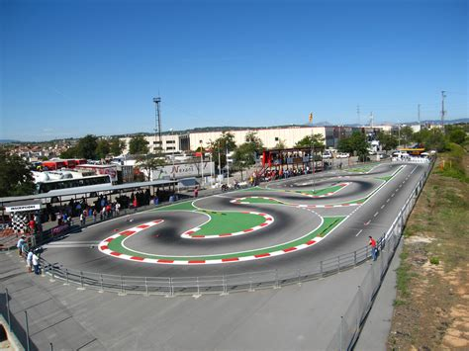
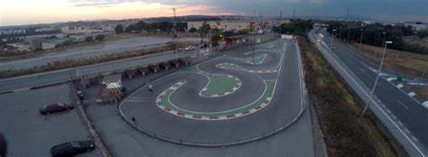
Hoteles cercanos.
https://www.eurostarshotels.com/exe-parc-del-valles.html?referer_code=ps0bg00ww&msclkid=958b044c4ce8167608e662bd1b168f09&utm_source=bing&utm_medium=cpc&utm_campaign=Exe_Gen_Exe+Parc+del+Valles_ES_Barcelona_002384_E012_ps0bg00ww&utm_term=hotel+cerdanyola+vall%C3%A9s&utm_content=Exe_Gep_Exe+Parc+del+Valles_ES_Barcelona_002384_E012_Prospecting
https://www.online-reservations.com/?hotelid=91128&gacc=gmcc&msclkid=96663c352573186c2ba75ac47de2281b&utm_source=bing&utm_medium=cpc&utm_campaign=Keyword%20Gaps%20-%20Dynamic%20Ads&utm_term=campanile%20barbera%20del%20valles&utm_content=Dec%208
https://www.hostalxarau.com/

No dispondremos servicio de bar. Os pasamos link de sitios cercanos
https://www.google.com/maps/place/Estaci%C3%B3+de+rec%C3%A0rrega+de+Galp/@41.5003365,2.1394673,18.25z/data=!4m14!1m7!3m6!1s0x12a4974982990e9d:0xcdf04288ce086107!2sLoro+Charly+Ripollet+Restaurant!8m2!3d41.501121!4d2.139609!16s%2Fg%2F11gj76wv6j!3m5!1s0x12a495e49f24651b:0x2718d031b420dc9a!8m2!3d41.5014646!4d2.1393065!16s%2Fg%2F11mrjlxn_m?entry=ttu&g_ep=EgoyMDI2MDgwOS4wIKXMDSoASAFQAw%3D%3D

https://www.google.com/maps/place/Loro+Charly+Ripollet+Restaurant/@41.501121,2.1370341,17z/data=!3m1!4b1!4m6!3m5!1s0x12a4974982990e9d:0xcdf04288ce086107!8m2!3d41.501121!4d2.139609!16s%2Fg%2F11gj76wv6j?entry=ttu&g_ep=EgoyMDI2MDgwOS4wIKXMDSoASAFQAw%3D%3D

https://www.google.com/maps/place/Sushi+Hand+Cerdanyola/@41.5011476,2.1365008,16.5z/data=!4m14!1m7!3m6!1s0x12a4974982990e9d:0xcdf04288ce086107!2sLoro+Charly+Ripollet+Restaurant!8m2!3d41.501121!4d2.139609!16s%2Fg%2F11gj76wv6j!3m5!1s0x12a495a4ea630a95:0xf2f0a2c4208fcccb!8m2!3d41.501703!4d2.1381959!16s%2Fg%2F11zcxqqtrj?entry=ttu&g_ep=EgoyMDI2MDgwOS4wIKXMDSoASAFQAw%3D%3D

https://www.google.com/maps/place/Ca+La+Cristina/@41.5011476,2.1365008,16.5z/data=!4m14!1m7!3m6!1s0x12a4974982990e9d:0xcdf04288ce086107!2sLoro+Charly+Ripollet+Restaurant!8m2!3d41.501121!4d2.139609!16s%2Fg%2F11gj76wv6j!3m5!1s0x12a49600fbc81cb1:0xf69b0f2408809e5!8m2!3d41.499328!4d2.1421865!16s%2Fg%2F11xj82q9q?entry=ttu&g_ep=EgoyMDI2MDgwOS4wIKXMDSoASAFQAw%3D%3D

¡Esperamos vuestra participación en el evento y que disfrutemos de un buen fin de semana de carreras!



